Web Programming Project On

**“Quiz Game”**

**Submitted by: Prabhakar Kumar Submitted To: Mr. Ajay Yadav**

**UID: 24MCA20071 Course: MCA**

**Section/Group: 2/A Date Of Submission: 05/11/2024**

**July 2024 – November 2024**



**University Institute Of Computing Chandigarh University**

**Mohali, Punjab**

**Project: Quiz Game.**

1. **Introduction**

This code uses HTML, CSS, and JavaScript to create a straightforward but entertaining quiz game. This quiz's main goal is to assess users' knowledge on a variety of subjects by asking them a series of questions with multiple-choice answers.

1. **Objective**

The Quiz Game's goal is to develop an entertaining and interactive platform that allows users to test their knowledge on a variety of subjects by answering a series of multiple-choice questions. The following objectives are the focus of the game.

1. **Modules and Technologies Used**

The Quiz Game's functionality and user experience are enhanced by the integration of web

technologies and modular design principles. The main modules and technologies used in the

game's creation are listed below:

1. HyperText Markup Language, or HTML  
   Goal: The quiz game's structure is provided by HTML, which also specifies the elements like buttons, headings, paragraphs, and containers.  
   **Features Employed:**

<div> components for the quiz container's structure.

<h1> for the heading.

<bottom> for interactive answer options .

1. The quiz game's graphic components are styled using CSS (Cascading Style Sheets), which guarantees an eye-catching appearance and a responsive layout that improves user experience.  
   Features Employed:  
   Flexbox is used to align and center components inside the game container.  
   For visual appeal, use shadows, borders, and background colors.  
   To increase interactivity, apply hover effects to buttons.
2. JavaScript Goal: By managing user interactions, presenting questions, verifying answers, and keeping score, JavaScript gives the quiz game interactivity and dynamic behavior.  
   Essential Roles:  
   Question Display: The ability to dynamically display alternatives and questions according to the question index that is currently in use.  
   Answer checking is the application of logic to instantly deliver feedback by comparing user-selected answers with the right answers.   
   Score tracking: Using variable management, the user's score is tracked during the test.  
   Restart Functionality: The ability to restart the test so that it can be played again without requiring a page refresh.
3. Structure of Data  
   Array of Objects: The wording of the question, the right response, and any potential options are all contained in an array of objects that hold the questions and answers. The quiz data may be easily accessed and modified thanks to this standardized style.
4. Design that is responsive  
   Mobile-Friendly: The quiz game's responsive design makes it work well on a range of screen sizes, including computers and mobile devices, improving accessibility.
5. Mechanism for User Feedback  
   Real-Time Feedback: By verifying accurate responses and pointing out errors, the game offers players immediate feedback on their responses, improving learning.

**Code:-**

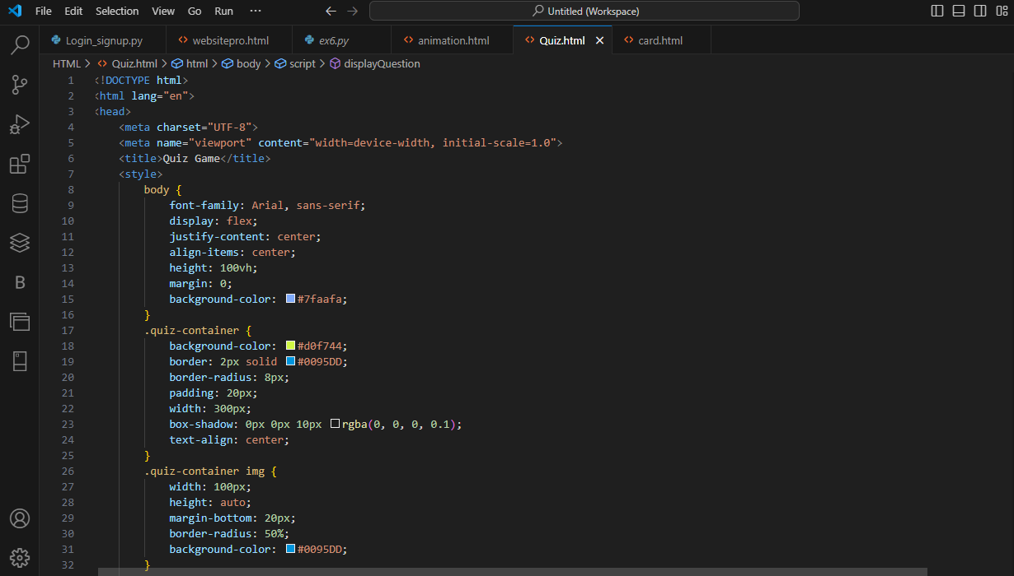

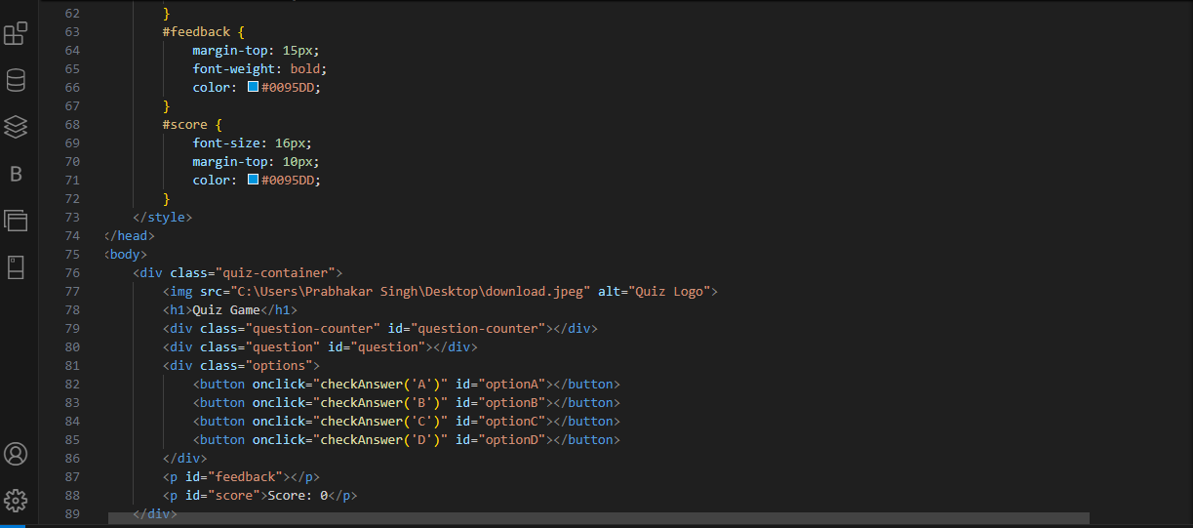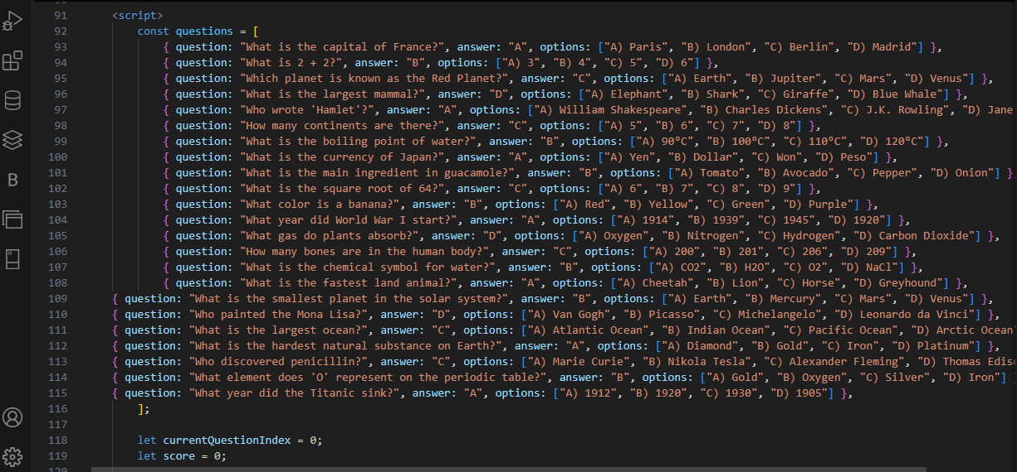

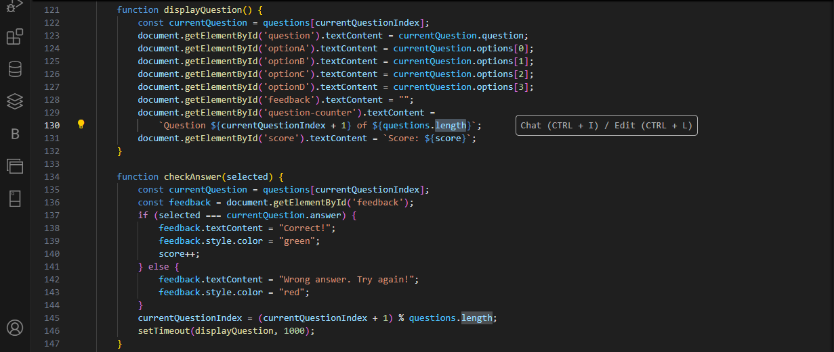



**OUTPUT:-**

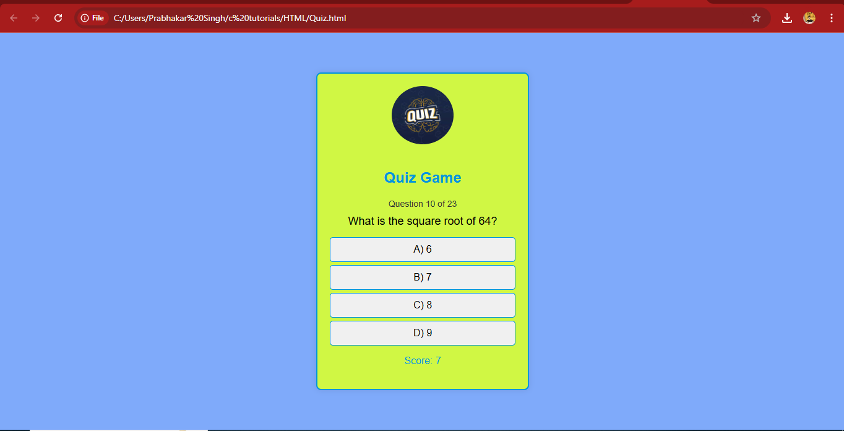

**Conclusion:-**

The Quiz Game is a powerful tool for involving users in an interactive learning process since it combines HTML, CSS, and JavaScript with responsive design principles and structured data management. More questions or features can be added in the future thanks to the modular design's easy modifications and scalability.